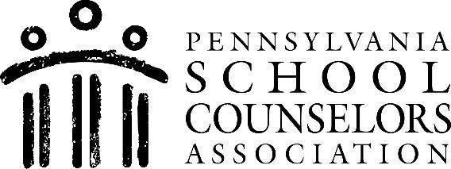 | Phone 412-612-3801  www.paschoolcounselor.org  epeiffer@paschoolcounselor.org

PSCA
One Scholarship Awarded
$1,000
2022 Scholarship Competition

Eligibility & General Guidelines:
- Participants should be high school seniors planning to pursue a post-secondary education.
- Please submit a one (1) page essay of no more than 500 words (single spaced, double spaced between paragraphs) on a School Counselor who has made a difference in your academic, career and/or social-emotional development.
- The School Counselor you are writing about must be a certified School Counselor, employed as such in Pennsylvania.
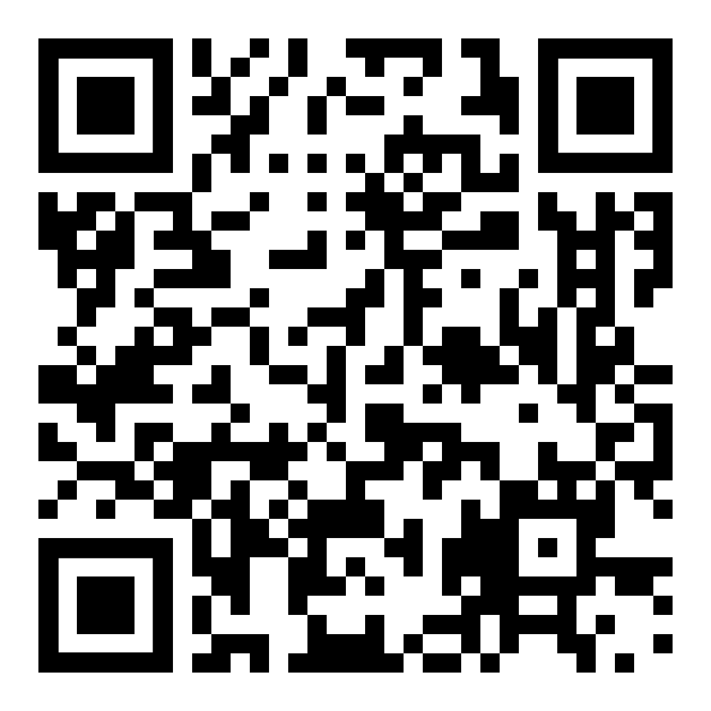
- ALL Essays must be submitted electronically at the link below.
- Create an account HERE to apply or scan the QR Code.

Deadlines:
April 1, 2022 11:59 PM- Deadline for submissions
May 6, 2022- Recipient announced

Questions can be directed to:
Mrs. Nicole Levis, School Counselor
Email: nlevis@avonworth.k12.pa.us
Phone: 412-847-0940.

*Chartered Division of the American School Counselor Association

